Where Did We Go?

We taught at Indianapolis Public Rousseau McClellan School #91, or IPS #91 for short. IPS #91 models their core beliefs, values, and mission after Maria Montessori’s philosophy of learning. A Montessori school means that the student is recognized as a unique individual undergoing psychological development in their early years of life. Their mission statement is as follows:
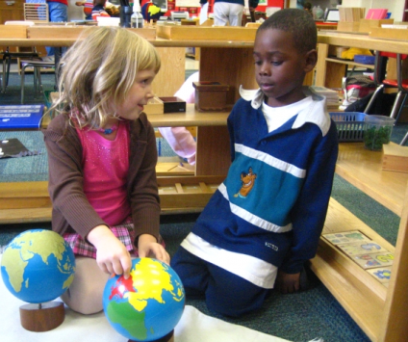
“…to prepare the whole child as a lifelong learner and problem solver in an ever-changing society by following the Montessori philosophy and method.”

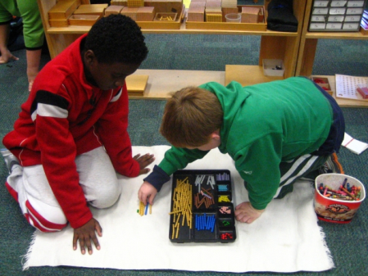
Maria Montessori’s education method involves free activity that tailors to the basic and specific characteristics of children at different ages, yet in a prepared environment. For example, the IPS #91 classrooms are orderly and clean to avoid overwhelming the student; in addition to, aiming to inspire the student to learn. They are equipped with individual cubbies for each students’ belongings and pieces of work. The classrooms lack formal desks to encourage movement, activity, and avoid monotonous structure. Students work at their own pace in uninterrupted manner. They must finish a checklist of criteria by the end of each month which teaches students time management and organization.
*Both of our students are enrolled in 2nd grade at IPS #91.*

