**I would like to introduce you to…**

RACHELLE

C:\Users\Brooke\AppData\Local\Microsoft\Windows\Temporary Internet Files\Content.IE5\0L39YHCN\MC900364504[1].wmf

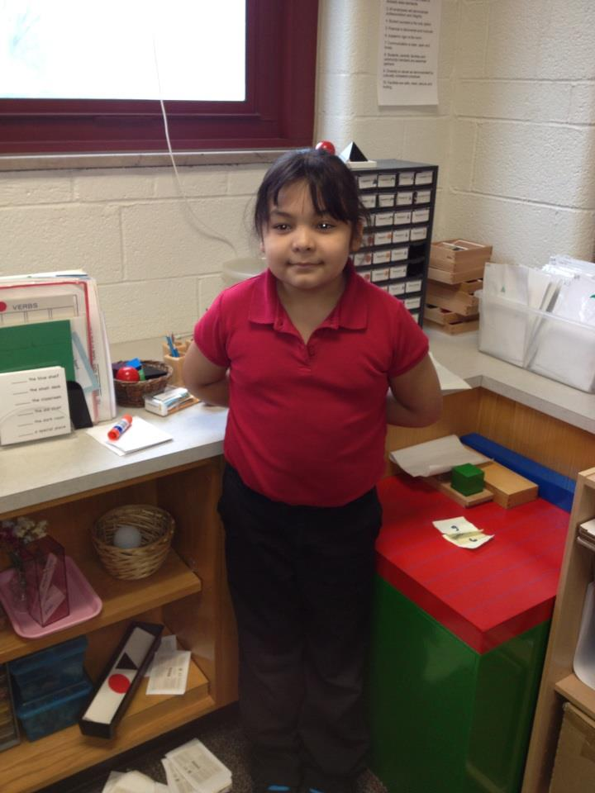

When I first met **Rachelle** on February 8th, she was very demure, quiet, and shy. However, as the weeks progressed and we were able to appreciate each other on a more personal level, Rachelle truly **blossomed out of her shell** and welcomed us, her Butler Friends. Establishing this relationship with Rachelle allowed me to understand her learning style AND bring about the **passion to learn**.

Rachelle learns best through **interaction and physical activity**. This makes her a **BODILY-KINESTHETIC** learner. Noticing this, Ms. Kaitlin and I incorporated activities that integrated **moving and learning** at the same time. One day, I created a series of movements that encapsulated the Tomato Growth Cycle and Rachelle easily and effortlessly followed along. On a separate day, we dissected a tomato and planted tomato seeds in a pot. Rachelle was completely **engaged** in the **hands-on activities**. Receiving a response like that is more rewarding than you would think as an educator. I didn’t realize how correct the cliché statement that “learning can be fun” is until I was placed in a teacher environment.

As stated before, she was rather introverted when I first met her, like how many people naturally act when they meet someone new for the first time. I immediately noticed that Rachelle was an **INTRAPERSONAL** learner. She is very in tune with her feelings and understands what **motivates** her. She is quite the **independent learner**; furthermore, she has a strong sense of **confidence** in her actions. We played a game called “The Tomato Game” which tested their knowledge of tomatoes and their interesting facts. Each question was followed by a long pause by Rachelle and I noticed by her **expression** that it was because she was **internalizing** her thoughts to be confident with her answer. As a teacher, I must be aware of this thought-process because I used to be the type of student who spoke or reacted without taking the time to think. Rachelle possesses numerous qualities that will take her far in her educational career. She has been such a **teach-able**, **considerate**, and **passionate** student over the past months.

C:\Users\Brooke\AppData\Local\Microsoft\Windows\Temporary Internet Files\Content.IE5\0L39YHCN\MC900364504[1].wmf

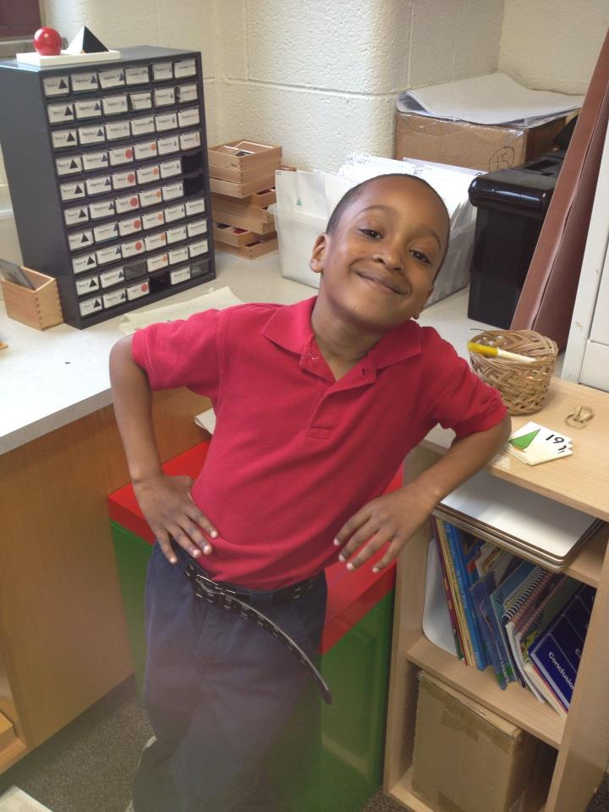When I first met **Anthony** on February 8th, he was ready to “conquer the world”. In other words, Anthony was **energetic** and **excited** to get started with us Butler Friends. I remember when we first met, he recalled two years ago when he visited Butler with that ED206 group. He raved about how much **fun** he had which posed as a challenge for this year. I was immediately eager to match and even surpass his previous experience. Anthony’s **quirky personality** kick-started our meetings and automatically displayed what type of learner he is. **INTERPERSONAL**. I observed that Anthony enjoys **interacting with others**. Often he would look around the classroom to see what activities the other groups were doing and then he would ask his peers about those activities after. Anthony is a **like-able, approachable** student that will hold intellectual conversations about any subject at hand and he challenged me to keep him on task.

**I would like to introduce you to…**

**ANTHONY**

One of Anthony’s **strongest talents** that I observed in the classroom is his **artistic abilities**. Our first lesson involved drawing a “Tomato Fact Web” and he drew the web intricately with **pictures** of **elaborate** tomato vines. His strongest learning intelligence is **VISUAL-SPATIAL**. Ms. Kaitlin and I worked activities that would bring forth his talents into the lessons, such as the Swapping Book activity. This activity involved beginning a story about tomatoes on the first page of an empty book and drawing a picture that corresponds to the events. Then the students swapped their books and continued their classmate’s story. Anthony grabbed a pen and began drawing immediately. We had to advise him to use a pencil to avoid permanent errors; however, Anthony was **confident in his drawing abilities**. Furthermore, he **excels** with handwriting because he incorporated bubble letters and cursive into his narratives. It was easy to utilize his strengths as a tool for **engaging** him into the lessons.

Anthony’s excitement for learning encourages educators to become passionate about teaching and vice versa. **His spunky personality is contagious**.