Reflection and Conclusion

Looking back on this past semester, I can honestly say that I have grown exceptionally in areas that I thought would take years of experience to develop. I have learned various techniques, strategies, and lessons that I hope to transfer into my future classrooms in order to reach my philosophical goals. Throughout my course work this semester, I have begun to form a personal definition of my teacher image via application, concrete experiences, and reflection.
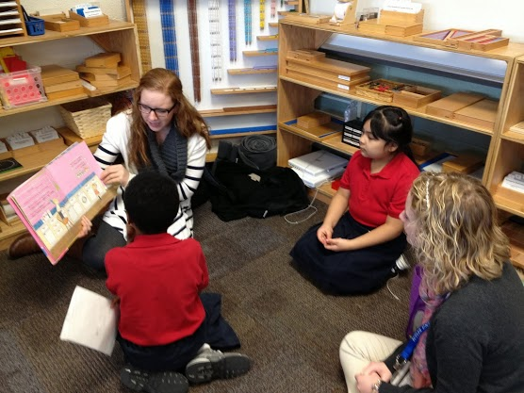
This class has allowed me to not only work towards determining my beliefs about what teaching is, but also add and reshape some aspects of my philosophical statements. As an aspiring teacher, I want to be able to leave a positive impact on my students. I have begun to experience working with children on a more intimate level, while slowly gaining confidence and exploring concepts from this course. One of my core beliefs involve the idea that enthusiasm makes learning more exciting and helps students find the pleasure in learning. This is a major checkpoint I want to meet in my future classrooms and ED206 has allowed me to become one step closer. Here are a couple of things:
I’ve learned many teaching techniques from class observations and discussions while visiting IPS #91. I enjoyed having classmates point out certain aspects of our “automatic teacher mode” that I haven’t noticed before, such as proximity and closeness, calm tones, measuring the pace of lessons, and noticing the differences between introverts, extroverts, and ambiverts.
I learned the importance of being flexible and “quick on my feet” while teaching a lesson to students at IPS #91 on March 1, 2013. On this particular day, we were informed the students were to attend an Irish Step Dancing assembly and our lesson plans were to be cut in half. I had to adjust my lesson plan the prior week because Rachelle, one of my two students, was absent. As teachers, we must expect the unexpected at all times. Students will be missing class, weather will affect class time, assemblies and other meetings will arise, and students might have exceptionalities. The ability to be flexible has been one of the most important skills I will take away from this class.
I learned how to structure a lesson plan on the second day of class via the Moodle Lesson Plan Construction Guide. This guide has been extremely helpful and has calmed my nerves about creating lessons. However, I did learn that teachers can use basically any design for a lesson plan, including charts and diagrams.
I learned how to co-teach with my partner which is an experience I have never encountered while teaching. It’s not only useful having an extra set of hands while teaching, but also having someone with different ideas and perspectives about each lesson. I would say the hardest part about co-teaching is deciding on one idea because we are both constantly throwing out different activities with integrated arts. Co-teaching is definitely something I want to continue being a part of until I can fully teach on my own.

